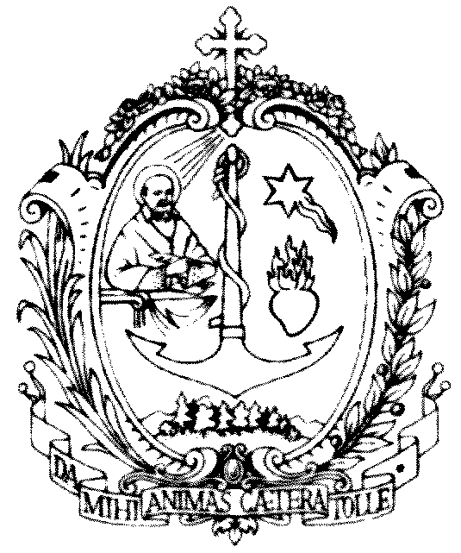
SOCIETY OF ST FRANCIS DE SALES
salesian heaquarters
Via Marsala 42 - 00185 Rome
Postulator General
for the Causes of Saints

ADDRESS TO THE SALESIAN FAMILY SPIRITUALITY DAYS 2022

in the light of the strenna

This year’s Strenna “Do all through love, nothing through constraint”, dedicated to St Francis de Sales for the 4th centenary of his death is a great gift for the Salesian Family. Don Bosco “chose as his inspiration and patron as with his work and writings he proposed that Christian humanism and that expression of charity which corresponded so well to his intimate aspirations. It is a humanism that does not ignore man’s weakness, but is based on an unshakeable confidence in the intrinsic goodness of the individual who is loved by God, and by Him called to Christian perfection, in every state of life. This humanism is a constitutive element of the charismatic and spiritual experience of the Groups founded by Don Bosco, and as a precious inheritance has been made their own by the other Groups which today are aggregated to the single Family. The whole Salesian Family, therefore, enters into this large movement, offering to the Church an original contribution in the field of education and in apostolic work (Charter of Charismatic Identity of the Salesian Family of Don Bosco no. 7).
He and his teaching convey an impression of rare fullness, demonstrated through the serenity of his intellectual research, but also the richness of his affections, the “gentleness” of his teachings that have had a great influence on the Christian conscience. Certainly our journey of holiness and the promotion of our Salesian Family’s Causes of Beatification and Canonisation draw great inspiration and strong motivation from him.
Belonging completely to God while living fully in the world
This is probably the most “revolutionary” of St Francis de Sales’ proposals. This was expressed with his usual depth and beauty by Pope Emeritus Benedict XVI when he said that the great invitation that St Francis de Sales addresses to Christians is that of ‘belonging completely to God, while living to the full [our] presence in the world and the tasks proper to [our] state. “My intention is to teach those who are living in towns, in the conjugal state, at court …” (Preface to the Introduction to the Devout Life). The Document with which Pope Leo XII, more than two centuries later, was to proclaim him a Doctor of the Church, would insist on this expansion of the call to perfection, to holiness. It says: “[true piety] shone its light everywhere and gained entrance to the thrones of kings, the tents of generals, the courts of judges, custom houses, workshops, and even the huts of herdsmen” (cf. Brief, Dives in Misericordia, 16 November 1877). Thus came into being the appeal to lay people and the care for the consecration of temporal things and for the sanctification of daily life on which the Second Vatican Council and the spirituality of our time were to insist. The ideal of a reconciled humanity was expressed in the harmony between prayer and action in the world, between the search for perfection and the secular condition, with the help of God’s grace that permeates the human being and, without destroying him, purifies him, raising him to divine heights” (Benedict XVI, General Audience, 2 March 2011).

Pope Francis, too, in his Apostolic Exhortation Gaudete et Exsultate on the call to holiness in today’s world, tells us: “We are frequently tempted to think that holiness is only for those who can withdraw from ordinary affairs to spend much time in prayer. That is not the case. We are all called to be holy by living our lives with love and by bearing witness in everything we do, wherever we find ourselves. Are you called to the consecrated life? Be holy by living out your commitment with joy. Are you married? Be holy by loving and caring for your husband or wife, as Christ does for the Church. Do you work for a living? Be holy by labouring with integrity and skill in the service of your brothers and sisters. Are you a parent or grandparent? Be holy by patiently teaching the little ones how to follow Jesus. Are you in a position of authority? Be holy by working for the common good and renouncing personal gain. Let the grace of your baptism bear fruit in a path of holiness. Let everything be open to God; turn to him in every situation. Do not be dismayed, for the power of the Holy Spirit enables you to do this, and holiness, in the end, is the fruit of the Holy Spirit in your life (cf. Gal 5:22-23). (GE nos. 14-15).

From Don Bosco until today there is a tradition of holiness that deserves attention, because it is the incarnation of the charism that originated with him and that has been expressed in a plurality of states and of life and forms. It is a question of men and women, young people and adults, consecrated and lay people, bishops and missionaries who in different historical, cultural and social contexts in time and space have made the Salesian charism shine with a special light, representing a heritage that plays an effective role in the life and community of believers and for all people of good will.

In 2022 we remember:

The 4th centenary of the death of St Francis de Sales (Lyons, 28 December 1622).

175th anniversary of the birth of Blessed Madeleine Morano, a Daughter of Mary Help of Christians (Chieri, 15 November 1847). When she made her perpetual profession in 1880, she asked God for the grace “stay alive until I have achieved the required degree of holiness”.

150th anniversary of the birth of Blessed Joseph Calasanz (Azanuy – Spain, 23 November 1872), leader of the Spanish martyrs. At their Beatification, St John Paul II said: “The saints' lives and the martyrs' witness teach us that if the transfiguration of the body will occur at the end of time with the resurrection of the flesh, that of the heart takes place now on this earth with the help of grace. We can ask ourselves: What are "transfigured" men and women like? The answer is very beautiful: they are people who follow Christ in living and dying; who are inspired by him and let themselves be imbued with the grace that he gives us; whose food is to do the Father's will; who let themselves be led by the Spirit; who prefer nothing to Christ's kingdom; who love others to the point of shedding their blood for them; who are ready to give him their all without expecting anything in return; who – in a word – live loving and die forgiving.”

125th anniversary of the death of Venerable Andrew Beltrami, Salesian of Don Bosco (Valsalice, Turin, 30 December 1897). Very precise in his observance of the Rule, he had an ardent love for Don Bosco and the Congregation. In the four years he lived after his priesthood he continued to pray and write. The Italian translation of the first volumes of the critical edition of the works of St Francis de Sales is worthy of note.

100th anniversary of the birth of Servant of God Rosetta Marchese, Daughter of Mary Help of Christians (Aosta, 20 October 1922). In a letter to her spiritual director, the Servant of God Bishop Francesco Fasola she wrote: “Thank you for what you have given me over these twenty years; oh how I have learnt from you the love for Jesus, Mary, the Church, for souls! How I have learnt to explore the gentleness of St Francis de Sales and the need for total gift of myself to Jesus through Mary!” (letter of 12 January 1981).

50th anniversary of the death of Servant of God Joseph Cognata (Pellaro - Reggio Calabria, 22 July 1972), Salesian bishop, founder of the Salesian Oblates of the Sacred Heart. Even in the hour of trial and calvary he spread light, courage, confidence and joy in an all-embracing fatherliness. He was a noble figure, rich in doctrine, wisdom, and the holiness of the gentleness of St Francis de Sales.

50th anniversary of the Beatification of Michael Rua (Rome, 29 October 1972). As St Paul VI said in his masterful homily for the Beatification: “He was the first successor of Don Bosco, the saintly founder of the Salesians… his son, disciple, imitator; along with others, as we know all too well, but first among them, he made a school out of the saint’s example, and of his personal work he made an institution that expanded, we could say, worldwide; of his life he made a history, of his rule a spirit, of his holiness a type, a model; of a spring he made a current, a river...”

50the anniversary of the death of Venerable Attilio Giordani (Campo Grande – Brazil, 18 December 1972), a Salesian Cooperator and layman who embodied the spirit of the Oratory in his family, work, oratory and mission.

commitment
As Salesian Family we wish to revive the great theme of the universal call to holiness, highlighting the variety and multiplicity of vocations found in the Groups in our charismatic Family. It is good to remember that almost half of the 32 Groups have a Cause of Beatification in progress. We wish to promote the heritage of holiness in the Salesian Family which has sprung from Don Bosco's charism, spreading knowledge and imitation of and devotion to the members of the Salesian Family who are saints and candidates for holiness.

Let us entrust ourselves to the intercession of St Francis de Sales

Saint Francis de Sales, Bishop and Doctor of the Church, who by your life and words enlightened so many souls, guiding them, with strength and gentleness, along the path of evangelical perfection, teach us today, too, to follow the Lord more closely.
You said: “Make your Saviour the heart of your heart”, so help us to walk in the ways of love, so that our faith may never be dry and without ardour but always led by the divine charity which makes our relationship with the Lord a relationship of those who are in love.
You said: “Ask for nothing and refuse nothing”, so sustain our desire to live in trusting abandonment to God's will, certain that everything is grace, the mysterious but true sign of the love with which the Lord accompanies our lives.
You said: “There is no greater difference between the Gospel and the lives of the saints than there is between written music and sung music”, so remind us of the beauty of holiness, the joy of a life lived according to God in all respects.
You said: “It is in prayer that we learn to do what we do well”, so accompany us every day so that we do not forget the primacy of prayer, the importance of growing in the spirit of prayer which is the true foundation of our faith.
You said: “All that is not for eternity is nothing but vanity”, so prevent the realities of this world from distracting us from Heaven, the happy goal of our earthly pilgrimage.
You said: “Our misery is the throne of God's mercy”, so maintain in us the serene hope that God's love is always greater than our poor hearts.
Most gentle shepherd, intercede for us with the Lord, “God of the human heart”. Bring our desires and intentions before him,and watch over us in your spiritual friendship. Amen.
(Bishop Guido Marini)

